Fiora Chan

SE 195

5 June 2020

COVID-19 Effects on Internet & Communication

*Introduction­­*

COVID-19 has affected everyone’s life, more or less. My phenomenon of interest lies in how COVID-19 has changed the way people use the internet to communicate with one another. I want to study what are people using the internet for during this time? Are they using the internet for communication purposes, entertainment, learning, social media, researching, or for other means? Which one of these categories have increased or decreased due to COVID-19? COVID-19 has changed the way we communicate because of stay-at-home orders, so how is this changing the internet? Are people using the internet more or less to communicate with each other and how? Are they texting, video calling, or maybe even writing letters rather than using the internet?

I chose to study the way COVID-19 has affected the way people use the internet to communicate because COVID-19 has affected everyone and is an important matter at this time. It’s affected everyone in the world, no matter where you are and no matter what your background is. People are generally social creatures and thus communicating with one another is important for us. COVID-19 does not allow us to communicate with people face-to-face (for the most part) and thus people may resort to other resources such as the internet to communicate with others. I believe that it would be interesting to see how COVID-19 has affected the way people internet and communicate via online.

Not only did I find it interesting, but I think it would be important to know this information to continue my journey to becoming a UI/UX designer (user interface and user experience designer). Being a UI/UX designer is not just about designing, but researching plays a huge role in the process. Part of researching is about looking up applications or websites that are similar to the one a designer is working for and seeing what are the pros and cons of their app or website. In addition, it’s important to keep up with the trends and lifestyle changes that people have in order to make a UI/UX that the users will want to use and will find it helpful for their life. I believe that by studying how COVID-19 has changed the way people internet and to study why some applications or websites have more users than others will allow me to practice my research skills.

The different broad categories that will be examined are communication, entertainment, and social media. Different forms of communication such as emailing, messaging, and video calling have all change during COVID-19. Entertainment can include streaming, gaming, and more. The different forms of entertainment on the internet have increased. Lastly, social media has a mixed change. Some social media sites have increased while others have decreased. However, the way people use social media has changed. There’s a new purpose for social media during COVID-19.

Although research has been done worldwide, I will be focusing on the U.S. population. There have been studied comparing different cities in the U.S., but most of the trends in U.S. cities have been similar, so I will focus on the U.S. population as a whole.

*Social Observation*

COVID-19 has changed the way people communicate, especially over the internet. Overall, the internet usage has gone up, but we use the internet to communicate in different ways that we usually would. COVID-19 has caused a significant impact on the way people internet. People became more depend on the internet during the pandemic, but not all aspects of the internet went up, some went down as well.

In general, the internet usage went up during the pandemic. Verizon did a study comparing the internet usage of January and March. The March internet usage is consistently more than the January internet usage. The stay-at-home orders started in March, so this shows that people have used more internet since the lockdown. Not only did the internet usage go up, but people became more dependent on the internet. A survey conducted by Pew Research on March 19-24 found that 93% of Americans say that an interruption to their internet or cellphone service during the pandemic would cause trouble in their daily life. This means that people are being dependent on the internet during this time. More interestingly, they also found that 64% of Americans think that the internet and cell phone services will help during this time, but are not a replacement for face-to-face encounters. On the other hand, 27% of the U.S. adults said it will be just as good as in-person contact. The last 8% of the people said that the internet won’t be much of a help in communication (Anderson & Vogels, 2020). For the most part, gender, age, economic status, and race doesn’t play a huge difference in these percentages. Majority of the U.S. population think that the internet has helped people connect during this time, but it will not stay this way forever as people do not believe that it will replace in-person contact in the future. The people who found that the internet won’t be helpful may think that it’s completely different from in-person contact, so don’t find it helpful at all. The initial reason could be that older generations don’t do as well with technology, so they do not find it helpful, but all age groups voted in similar patterns.

More specifically, email and messaging were one of the aspects of the internet that went up. According to the same Pew Research, they found that 76% of U.S. adults used email or messaging to communicate with others (Anderson & Vogels, 2020). A New York Times article also stated that “it seems that we want to do more than just connect through messaging and text – we want to see one another” (Koeze & Popper, 2020). Although people were using email and messaging to communicate, it did not increase by a significant amount. On the other hand, video calling increased by a significant amount. New York Times compared a few video chat applications and websites before and after the first U.S. COVID-19 death. Google Duo had roughly 3.9 million users on January 15 and over 4.5 million users by March 24. In a similar fashion, Nextdoor.com had roughly 3.7 million users before and close to 5.0 million users after the lockdown. Houseparty had a 79.4% increase since the quarantine. This shows that people are looking to video calling to communicate with family and friends rather than just texting. This changed the way we communicate because texting and emailing was not enough. People wanted to see each other’s faces.

Social media is also another form of communication. There has been somewhat of an inconsistent number in social media usage. One study shows that social media has increased 40.88% from February 16 to March 29 (Bergman & Iyengar, 2020). Verizon did a study where they found that the social media usage did not increase or decrease during this time. I could see it going both ways because people have more time on their hands and thus will most likely spend more time on social media. It could also be that people don’t have much going on, so they don’t post as much on social media; this could lead to less time on social media sites because there’s not much new being posted. Although the social usage time change is uncertain, what’s interesting is that there is a change in the use of social media. In a competitive analysis by Rival IQ, they found that the engagements on Instagram, a social media website were different. They compared the median engagement rates per post in different categories. There was a week by week comparison from January 5th to May 2nd. Alcohol has had a bit of an increase in engagement rates as the pandemic continues. Food and beverage has gone down from 0.9% to 0.55% in median engagement rate per post. Financial services, health and beauty, and home décor have all fallen in engagement rates, in a similar fashion to food and beverages. On the other hand, higher education has gone up and down from around 2.9% to 3.5%. Although it has bounced around, it still has roughly 3x more engagement than the other categories on Instagram. In addition, there has been much more engagement in March and April than in January and February. This shows that the focus on Instagram has changed from focusing on other aspects on life and now has focused on higher education information. This could mean that people are looking up information about how coronavirus is affecting them or possibly the world. People shifted their focusing on everyday life things to focusing on scientific information on the coronavirus. This study also looked at Facebook and Twitter. Facebook and Twitter had a similar pattern to Instagram where higher education engagement posts went up while every other aspect went down. Engagement rates on Facebook and Instagram went down in general, while Twitter was able to sustain users. This is because people are turning to Twitter for news and updates because “it feels more instant than algorithm-heavy Facebook and Instagram” (Feehan 2020). Twitter is also where people can connect with brands and organizations right away where Facebook and Instagram seem to be used to connect with family and friends.

Social media is generally used to show family and friends what a person has been up to. On the occasion, it might be used to spread awareness and causes. Since the coronavirus, even scientists have used social media to collaborate with others and to spread information about coronavirus and the quarantine. Social media can “fuel scientific collaboration, create fundraising opportunities, and most importantly – help the quarantined people overcome their isolation” (Sokolov, 2020).

Gaming is another aspect of the internet that has increased. A study, comparing the week of February 10-16 and March 23-29, found that gaming has increased 28.54%. Twitch.tv is a streaming platform for gamers. According to New York Times, Twitch.tv has increased 19.7% since the lockdown. On January 15, Twitch had roughly 5 million users daily and on March 24, there were roughly 5 million users daily. Overall, this shows that people are spending more time on gaming. It could be related to the fact that people cannot go out, so they spend time at home gaming. Gaming could be a single person activity, but it could also be a social activity. However, since Twitch is a streaming service where a person streams themselves gaming and people watching can chat with others. It seems like people are using gaming to interact with one another as well.

Streaming and movies have also increased. Netflix has seen a 15.8 million subscriber increase, giving them a total of 182 million subscribers worldwide (Alexander, 2020). The percentage change between the weeks of February 10-16 and March 23-29 for streaming was +29.6%. This proves that there have been an increase in video streaming websites such as YouTube, Netflix, Hulu, and Disney Plus. In terms of communication, it is uncertain if people are communicating more or less. If people are watch these streaming services with the people who are living with them, then it could be a way of spending time with one another. There is a feature of Netflix called “Netflix Party” where people could watch shows on Netflix together. The two parties would view the same movie at the same exact time with a chat feature, so they can communicate as well. This two options could mean that these online steaming services are helping people communicate in this time of crisis. However, if people are watching these streaming services on their own, it could mean that the internet is isolating people more and thus not helping with communication during the pandemic.

Overall, internet usage has gone up, but the way we use the internet and the way we communicate over the internet is quite different. People are more dependent on their phone. Email, messaging, video calling, gaming, streaming, and movies have all gone up since the first cause of coronavirus in the U.S. Social media has fluctuated between different social media sites. The usage of internet has gone up because people are not allowed to go outside to enjoy the outdoors or enjoy time with friends and family in-person. They use the internet, such as emailing, video calling, and messaging to keep in touch with others. In addition, since they cannot go outside to spend their free time, they spend their free time on activities they can do indoors such as gaming, steaming, and movies. Social media is an interesting one. It’s uncertain whether social media has actually increased because there are so many different social media sites and some have increased while others have decreased. Different sources measure a different variety of social media sites and applications and thus some sources say social media have increased while some have decreased. Nonetheless, across the sources, social media have been changing in its purpose. Social media before focused on posting about people’s daily lives and updating family and friends about traveling, going to places, and lifestyle. With all the travel restrictions, shopping malls closing, and parks not opening, there isn’t much to post about their daily life. Instead, social media has been focused on the coronavirus and any information related to it such as how many cases there are in a certain area, whether stores are going to open soon, which restaurant is open for delivery, new stay-at-home orders, and more.

There are a variety of key influences that has shaped these key patterns. The biggest one is COVID-19. COVID-19 has caused people to lose jobs, stay-at-home, change their roles, and much more. Some people may have more time since they are working from home and some people may have to look for new jobs during this time. In the age of technology, the internet is used to find jobs and to also connect with others. Since the stay-at-home orders, most people have not been able to see their family and friends in real life. The next best thing may be using the internet to communicate with one another. Another key influence that shaped the social media usage could be the application and website itself. Some people may choose different social media sites and apps based on popularity or preference.

It’s proven that COVID-19 has affected the way people use the internet, but how is it affecting the way people communicate? The internet usage is not directly correlated to an increase in communication. It depends on which categories of the internet are using more. If people are only using video calling, texting, and emailing, then people are communicating through the internet more. However, entertainment and gaming are also increasing and those are generally more individual activities. Social media is not just about people’s personal lives and more about sharing posts about the coronavirus and stay-at-home order updates. Nonetheless, the internet has helped people stay entertained during a time when they can’t go outside for entertainment. The internet has also helped people communicate through text and video calling. It has helped keep people in touch virtually. It’s difficult to say whether people are communicating more through the internet, but it is certain that the internet has helped people communicate during this uncertain time.

*Professional Development*

In terms of professional development, my initial goals in my project were to develop my writing and research skills. I feel as if I’m not a very strong writer and hoped that this project would help develop my writing skills. More specifically, I feel like my writing could be improved on word choice and organization. I also wanted to develop my research skills. I want to be able tell which sources are more reliable than others and to be able to put together a variety of research articles together into one paper.

My career goal is to be a UI/UX designer for a tech company. A UI/UX (user interface/ user experience) designer creates the look and feel of applications and/or websites, so that users would want to use the application. As a UI/UX designer, you have to be able to understand people and be able to create aesthetic and easy-to-use applications and websites. Although designing the user interface is an important aspect, understanding the users and researching also plays a huge role in the job. This project can be helpful in the research aspect. This project will help me visualize how people communicate through different applications and websites and seeing how COVID-19 has changed the way people internet. I, now, have a better understanding of the social aspect of technology and understanding how real life situations can affect the way people use technology and the internet.

I feel like I learned a lot about how real life situations can affect the way people use technology and the internet. COVID-19 affects almost every aspect of life, but I didn’t think it would be such a big role in technology at first. After researching, I began to realize how much it actually affected technology. This project also helped me better understand the social aspect of technology. It made me realize that technology has to change as our society changes. For example, during COVID-19, people wanted to video call more than just messaging family and friends. This means that technology has to change in order to support more video calling rather than just messaging. These changes also have to be quick in order for the technology to thrive. These were the two aspects that I learned the most about. I feel like this will help me as a UI/UX designer because it’s important to understand how society changes will affect technology and I should be able to make these changes in designs as society changes and as changes like COVID-19 happen.

In terms of writing goals, I do not feel like I have improved as much as I wanted. Due to COVID-19, I was not able to attend class and get as much feedback on my writing. I also was hoping to attend the writing center to ask for help, but I did not get the chance to. I tried to face this challenge by practicing ways I can improve writing on my own. I read the paper out loud to myself to see if it sounded professional. Another aspect of writing I wanted to work on was organization. For the social observation of the paper, I focused on doing all my research in the beginning before I started my paper. After finishing all the research, I planned out on paper what different topics I was going to talk about and this helped me visualize my paper better and thus helped me with my organization. I wrote out all the topics and underlined them and put the points I wanted to make under them with bullet points. Then, I put numbers next to the topics, so that I knew the order of topics I wanted to talk about in my paper. I feel like I improved on the organizational part of writing, but I don’t feel like I’ve improved much as a writer. I want to further better my writing in terms of sentence structure and word choice in order to make my writing more professional and readable.

I was able to work more on my research skills more than my writing skills. I spend more time researching than anything else for this paper. Since COVID-19 is ongoing, I had to continually research and make changes when new research was found. I had to be able to keep up with the new information and research, which is an important aspect of research. There is always new resources and new scientific findings that may prove a previous finding incorrect. I have to be able to make these new changes. There were various times where I did research and found that the new data proved an old piece of data incorrect or that the new data says that COVID-19 actually affected something more than the old piece of data said. I learned that researching has to be an ongoing thing. As a UI/UX designer, researching will play a huge part. I have to interview users about what features a user needs or would like to see before creating it. I have to be able to understand users. I also have to be able to research similar applications and websites in order to do a competitive analysis. There will always be new applications and websites, so I have to keep up. I also have to research the design trends or else users may not use the application or website I am designing because it is out-of-date. I learned that researching is an ongoing process. I also learned that new information can prove old information incorrect and thus ongoing research is important.

Liz Fu is a product designer who just recently graduated University of Michigan in May 2020. She majored in UX Design and minored in art and design. She was able to study a multidisciplinary mix of courses in visual design, business, entrepreneurship, and user experience design. She also took summer marketing classes at the Haas School of Business at Berkeley and had pre-college experience at the Academy of Art University. She also has an impressing list of experience with a variety of companies. She was a design intern at Good Stuff Partners, a graphic design fellow at the University of Michigan, an experience design intern at Airbnb, and product design instructional assistant at the University of Michigan Center for Entrepreneurship. She has a few volunteer experience including a design consultant at We Help War Victims, a community volunteer at Matthaei Botanical Garden, and MLead Academic Volunteer at the University of Michigan. According to her LinkedIn, she has won many honors and awards such as the James B. Angell Scholar, Campus of the Future Finalist, Bicentennial ArtsEngine Award, and the Open Design Competition. She was able to take classes in Python, web interfaces, digital product design, human perception, interaction design, marketing, multimedia advertising, social influence and persuasion, typography, visual identity design, and branding. She has many endorsements in LinkedIn on graphic design, user experience design, and branding (Fu, n.d.). Liz Fu has various professional skills and related experience to make her work emulating.

All her volunteer work, work experience, and classes at the University of Michigan has shaped her strengths. I believe the experience design internship at Airbnb that she did was the most influential in shaping her strength. At Airbnb, she worked collaboratively with engineers, content strategists, and project managers to create a new feature to give experienced hosts the ability to create custom discounts for guests. Through her portfolio, you can see what she had to do and what she designed for the company. She talked about what she learned and talked about her experience. Throughout her portfolio, there are various times where she talks about food and sustainability. She talked about how there were culinary workshops on Airbnb Experiences (Fu, n.d.).

Liz Fu is a product designer and I want to be a UI/UX designer yet we have similar paths. A product designer’s role can be “a multidisciplinary ‘jack of all trades’ designer who does UX/UI, coding, project management and (perhaps most importantly) problem-solving” (Hannah, 2019). A product designer has more roles and those roles includes being a UI/UX designer. I think that one day in the long-run, I want to experience being a product designer. However, I really want to take it one step at a time with being a UI/UX designer first. Although Liz Fu says she is a product designer, she has taken UI/UX designer roles as well. She had multiple internships and experiences throughout her college career, which definitely helped her prove her strengths. I only have one internship under my belt. I interned with a UCI start-up company called VUSAR. VUSAR is working to create an augmented reality application for CAD (computer aided design). I was a co-UI/UX designer for the company for roughly 2 years. Although I really enjoyed my internship there, I want to follow what Liz Fu did in college. She had short-term internships and experiences, but she had a variety of experiences. When looking for a job now, I might want to look for contract work that lasts for maybe 6 months to a year. I want to be able to design for different companies because I think I would enjoy that. It would also help with expanding my interests by working for a variety of different companies. In addition, I really liked how Liz Fu’s portfolio included not only her designing work, but she also had an explanation of what she learned, her experiences and her roles. She also included information about what she liked outside of designing. She said she enjoyed coffee, sustainability, and learning about cooking. I also have to continue building my portfolio. I have an idea of what works I want to put in, but I also have to work on describing my thought process and talking about what I learned in different work experiences. I also really liked how she put some personality outside of design into her portfolio. That is definitely something I want to add, but I have not really been able to incorporate quite yet. I also really like how her projects incorporate not only her design passion, but also her passion for food and sustainability. Liz Fu did a design project on eco-friendly packaging for ramen. I thought this was meaningful and cool because it included all her different passions: design, food, and sustainability. I hope that one day I will be able to find a job where I am to design for some of my own passions such as photography and sustainability.

*Conclusion*

Important key observations and findings about how COVID-19 affected the way we use the internet for communication. It was found that people were dependent on the internet to communicate with others, even though a majority of people thought it won’t replace in-person contact. Messaging and emailing went up since the stay-at-home orders, but video calling usage significantly went upwards. Forms of internet entertainment such as gaming and movies has gone up in usage as people are not allowed to spend time outdoors. Some sources say that social media usage has gone up while others say it has gone down. More importantly, it is agreed upon several sources that the use of social media has changed. Many sources of social media is used to show family and friends what they have been up to, whether that’s traveling or their everyday life. People been posting less about their personal stories and more about coronavirus information and coronavirus stories. Social media is being used a form of news for coronavirus.

There were also important key observations and findings for myself while writing this research paper. I was able to work on my writing and research skills. I will take these research and writing skills into my professional life. I was able to understand further how social situations affect technology and the way people use technology. I believe that this skill will help me become a better UI/UX designer and to better create designs for people to use. I want to be able to create designs for applications that will better the lives of people.

Although I have learned a lot through this research paper, I still have a lot to learn and have a lot to make up because I was not able to have a field experience this quarter. I learned that writing and research skills are going to be valuable not only in life, but especially in my career. Research­­ has to be done before designing. If I do not do good research, then the designs likely will not be as great. Often, UI/UX designers have to pitch their design to software engineers, project managers, and even CEOs. In order to do so, they have to be able to be a good presenter and thus good with words. I believe being a better writer will be beneficial in my career. Since I did not get a field experience, I hope that I will be able to find UI/UX designer jobs with different companies so that I will have the chance to get different experiences. I will be taking this quarter’s research paper experience and field study experience into my professional life.

References

Alexander, J. (2020, April 21). Netflix adds 15 million subscribers as people stream more than ever, but warns about tough road ahead. The Verge. <https://www.theverge.com/2020/4/21/21229587/netflix-earnings-coronavirus-pandemic-streaming-entertainment>

Anderson, M., & Vogels, E. A. (2020, March 31). Americans turn to technology during COVID-19 outbreak, say an outage would be a problem. <https://www.pewresearch.org/fact-tank/2020/03/31/americans-turn-to-technology-during-covid-19-outbreak-say-an-outage-would-be-a-problem/>

Bergman, A., & Iyengar, J. (2020, April 8). How COVID-19 is affecting internet performance. <https://www.fastly.com/blog/how-covid-19-is-affecting-internet-performance>

Feehan, B. (2020, June 4). The impact of coronavirus on social media engagement for brands. Rival IQ. <https://www.rivaliq.com/blog/coronavirus-on-social-media-engagement-for-brands/>

Fu, L. (n.d.). *Airbnb experiences — Liz Fu*. Liz Fu Design. [https://www.lizfudesign.com/](https://www.lizfudesign.com/airbnb-experiences-internship)

Fu, L. (n.d.). Liz Fu. LinkedIn. <https://www.linkedin.com/in/lizfudesign/>

Hannah, J. (2019, March 11). What is the difference between a UX designer and a product designer? Become a designer, developer or analyst from scratch, with a job guarantee. <https://careerfoundry.com/en/blog/ux-design/what-is-the-difference-between-a-ux-designer-and-a-product-designer/>

Koeze, E., & Popper, N. (2020, April 7). The Virus Changed the Way We Internet. The New York Times - Breaking News, World News & Multimedia. <https://www.nytimes.com/interactive/2020/04/07/technology/coronavirus-internet-use.html>

Sokolov, M. (2020, March 3). The pandemic infodemic: How social media helps (and hurts) during the coronavirus outbreak. The Drum. <https://www.thedrum.com/opinion/2020/03/03/the-pandemic-infodemic-how-social-media-helps-and-hurts-during-the-coronavirus>

Journal

* Americans turn to technology during COVID-19 outbreak, say an outage would be a problem

(<https://www.pewresearch.org/fact-tank/2020/03/31/americans-turn-to-technology-during-covid-19-outbreak-say-an-outage-would-be-a-problem/>)

* + 93% say that a major interruption to their internet or cellphone service during the outbreak would be a problem in their daily life
  + Digital connections may provide an alternative during quarantine, but only a minority (27%) think that interesting via technology will be as effective as in-person contact
  + 64% of Americans think that internet and phones will help but are not a replacement for face-to-face encounters
  + Numbers from Pew Research Center survey of U.S. adults conducted between March 19-24

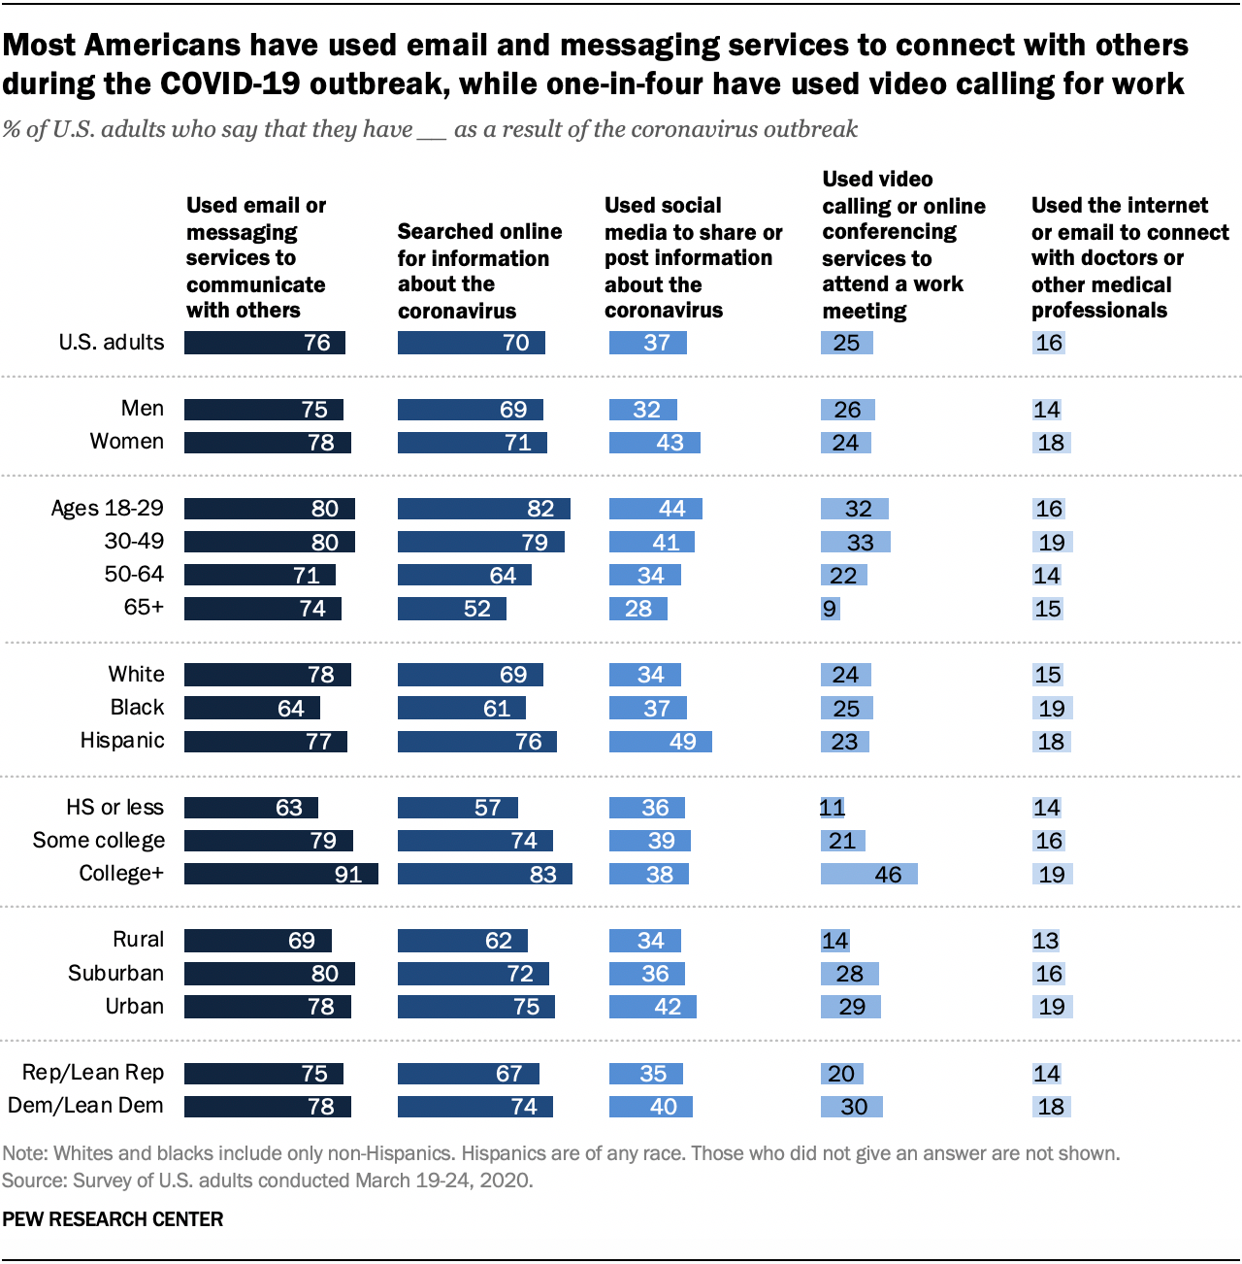

* + Differences by education level, age, and race, and ethnicity when it comes to technology
  + College graduates hold more virtual meetings than those with less formal education
  + 46% say they have participated in a work meeting by using video calling or online conferencing
  + More than half use internet to look up information about the coronavirus
  + Rural American less likely than urban areas to report using digital tools

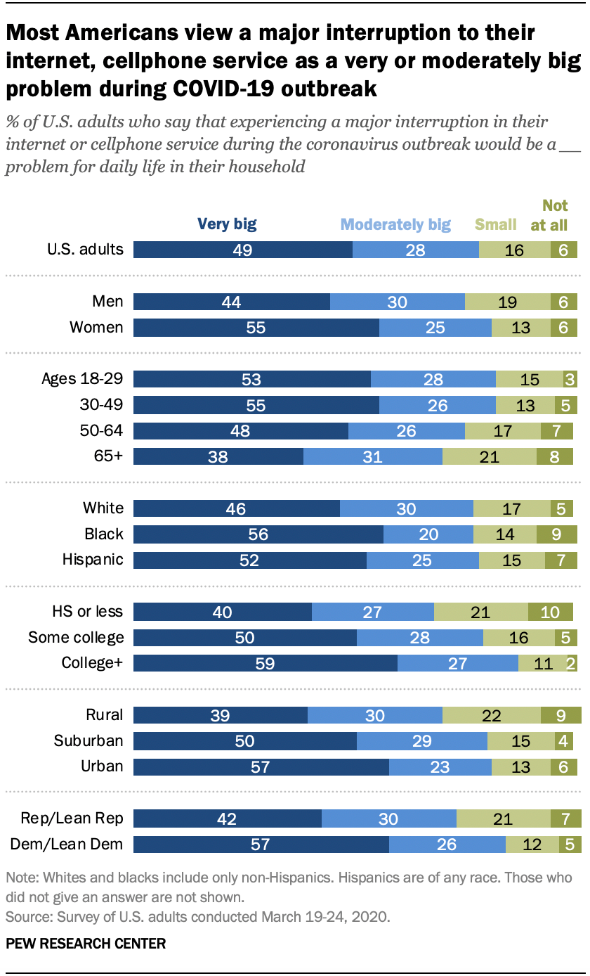

* + Most Americans see a major interruption to Internet and cellphone service as a very or moderately big problem during COVID-19

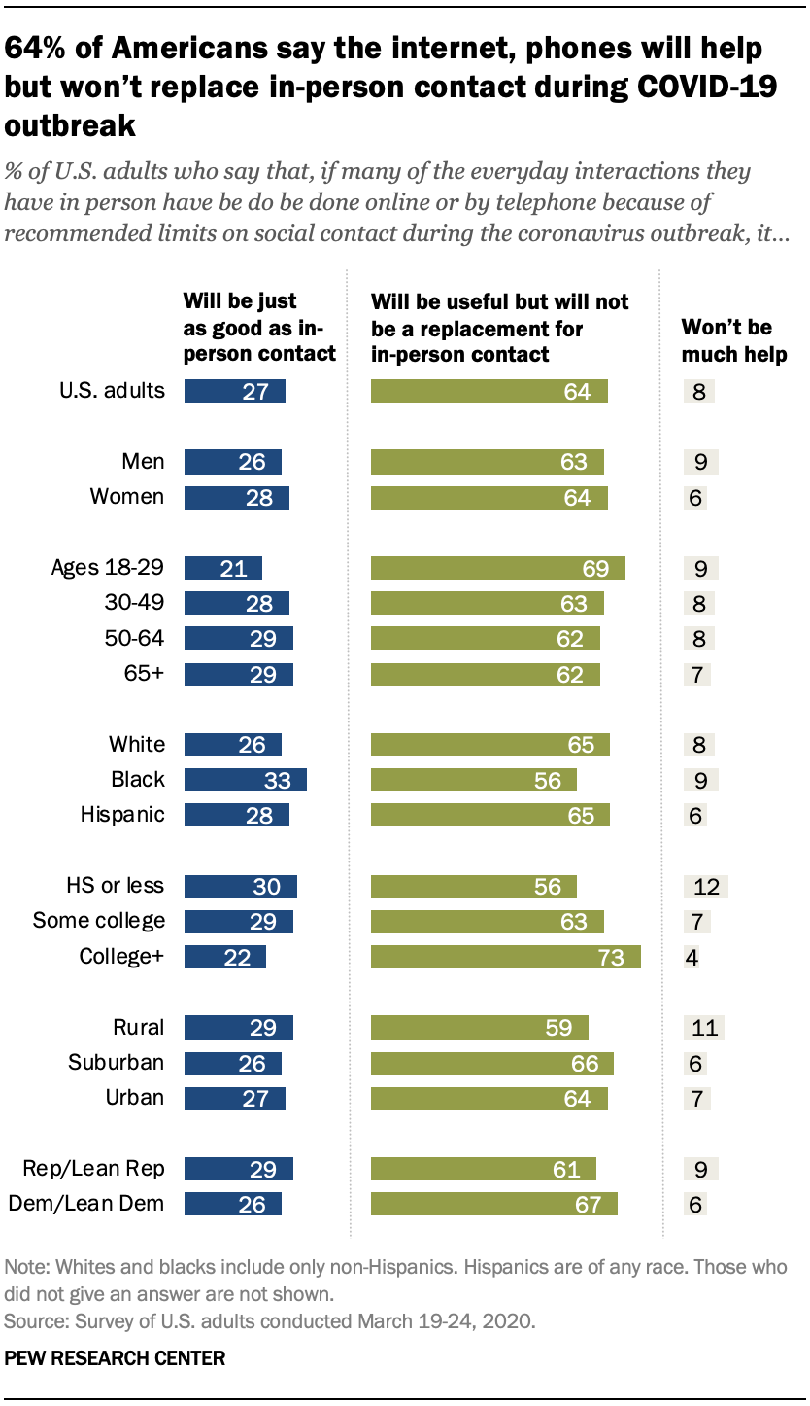

* + 64% of Americans say the internet, phones will help but won’t replace in person contact during COVID-19 outbreak
  + 27% say these technologies will be just as good as in-person contact
  + 8% says phone won’t help much during this time
* COVID-19 Pushes Up Internet Use 70% and Streaming More Than 12%

(<https://www.forbes.com/sites/markbeech/2020/03/25/covid-19-pushes-up-internet-use-70-streaming-more-than-12-first-figures-reveal/#475519db3104>)

* + Although sports events and concerts are cancelled, they are being replaced by streaming music and movies
  + “Increased consumptions of digital content from mobile apps to free TV streaming and gaming has already been observed in China and Italy” & “Online streaming services provided by brands such as Netflix and now Disney+ are likely to see 12% growth” (Maria Rua Aguete of Omdia, tech research arm of Informa Tech)
* How COVID-19 is affecting internet performance

(<https://www.fastly.com/blog/how-covid-19-is-affecting-internet-performance>)

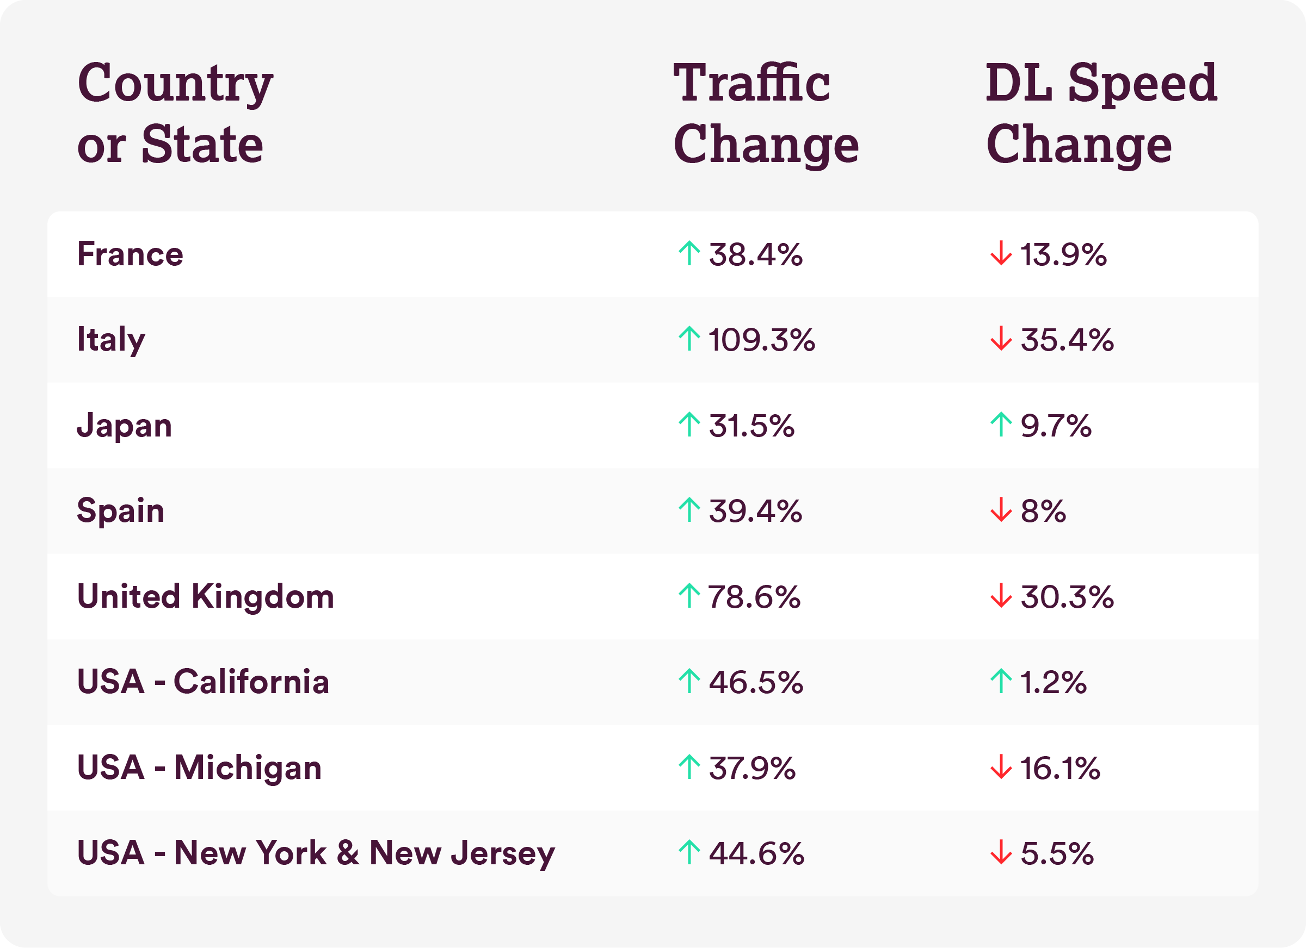

* + Proves that internet usage is going up in all countries

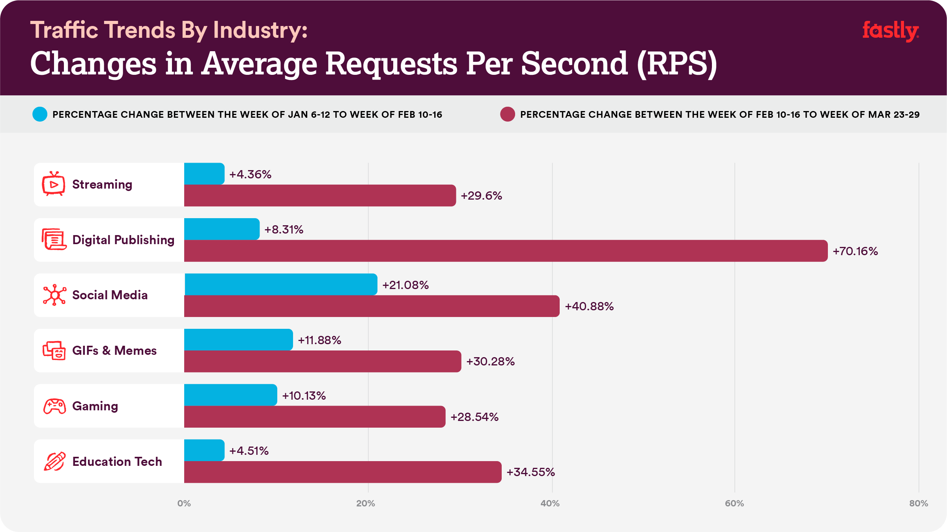

* + News and publishing sites averaged a 70.16% increase in RPS globally between February and March
  + Video streaming: 29.6% increase between February and March
    - This includes movies
  + Gaming: 28.54% increase in RPS between February and March
    - This includes game downloads, gameplay, including ability to speak with fellow gamers via VOIP
  + Education technology: average RPS increase of 34.55% between February and March
    - Includes homeschooling and virtual learning
* Home Internet data usage surges amid COVID-19 crisis

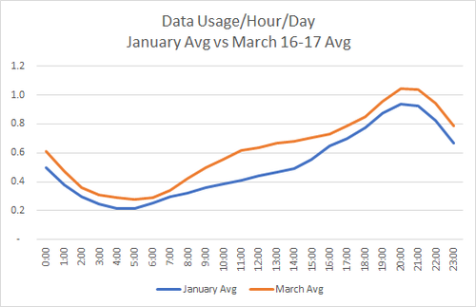

* Increase internet usage compared from January to March

*Based on peak data hour usage week over week. 
*Usage is expected to fluctuate over time; we could see new applications emerge based on customer usage patterns as more people telecommute and more students are at home. 
Source: Verizon


* Verizon did a study where they found 75% increase in gaming during peak hours, 12% boost in video streaming, and 20% rise in overall web traffic
* Social media was flat, even during peak usage hours
* The Virus Changed the Way We Internet (<https://www.nytimes.com/interactive/2020/04/07/technology/coronavirus-internet-use.html>)
  + New York Times analysis of internet usage in US from SimilarWeb and Apptopia, two online data providers, shows that we are using more internet

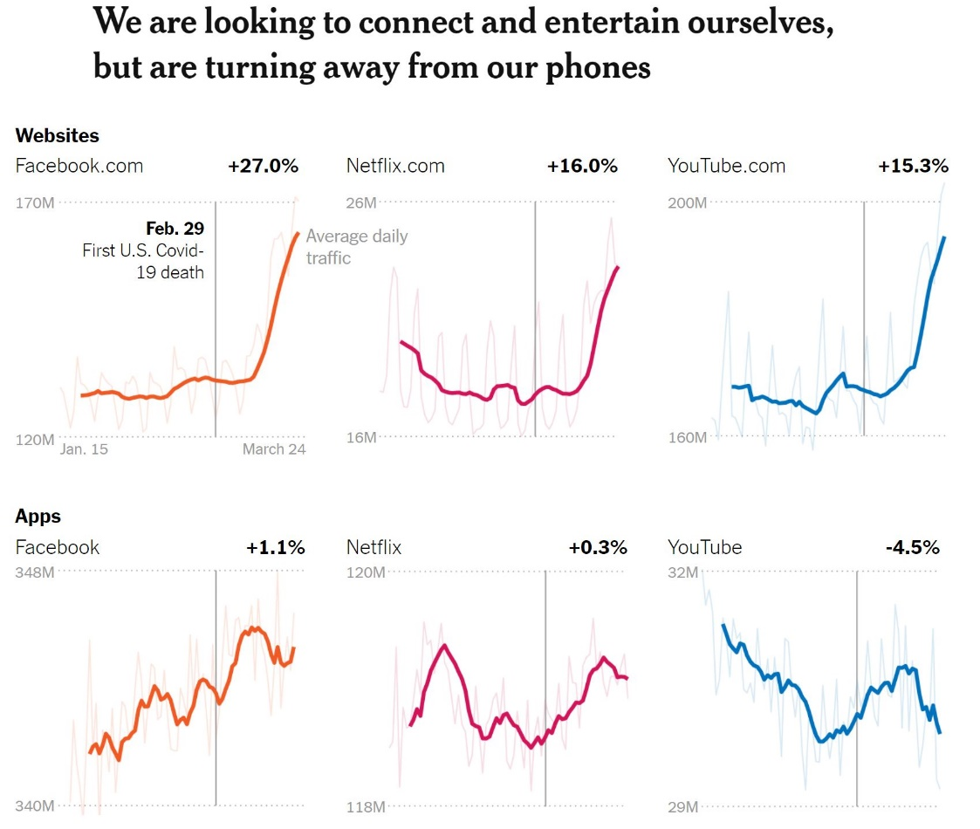

* + People are using more on websites rather than mobile devices

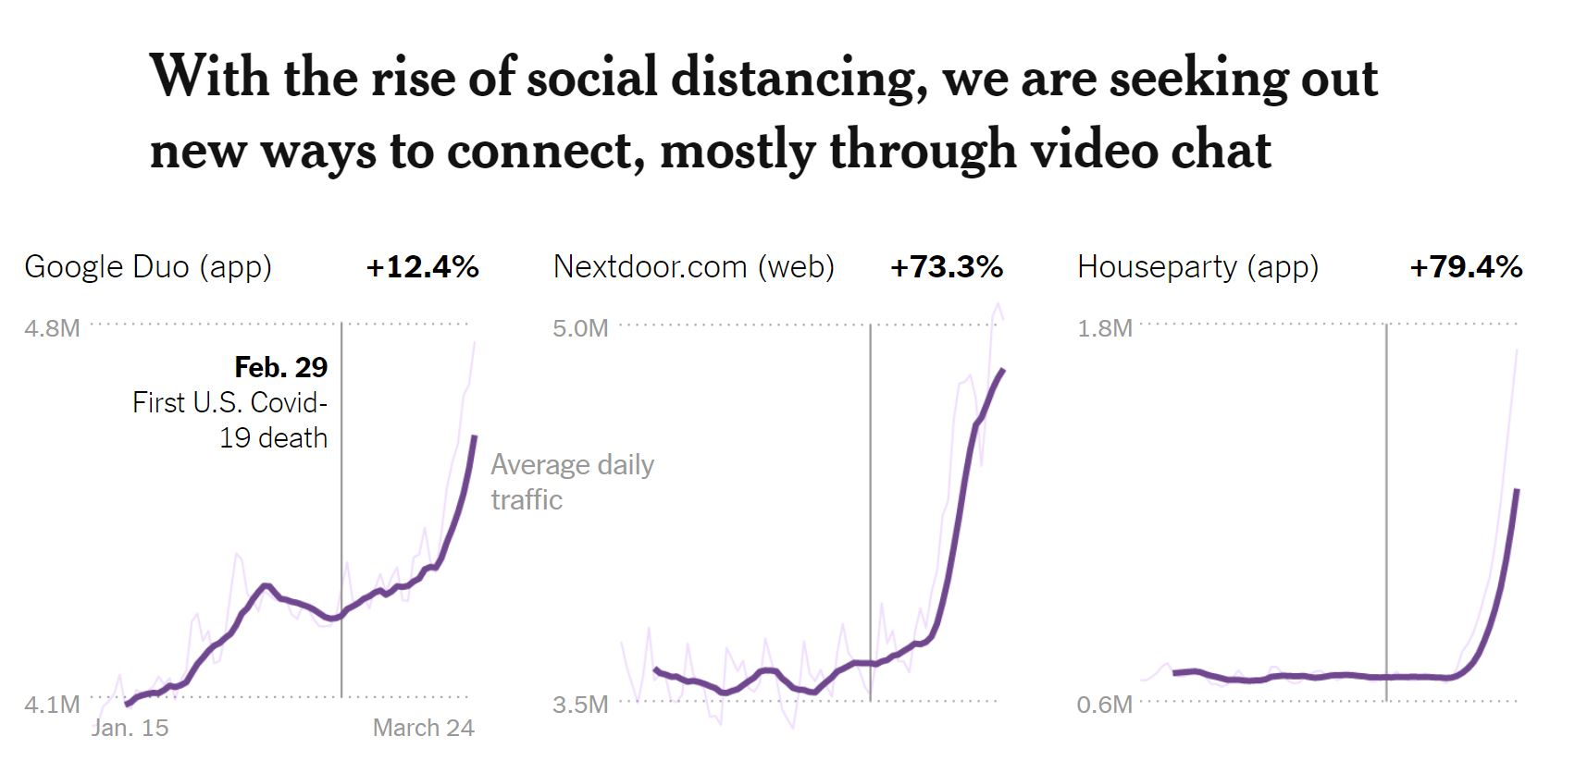

* + While traditional social media sites have been growing, it seems that we want to do more than just message and text---we want to see one another
  + Video chats have grown a lot

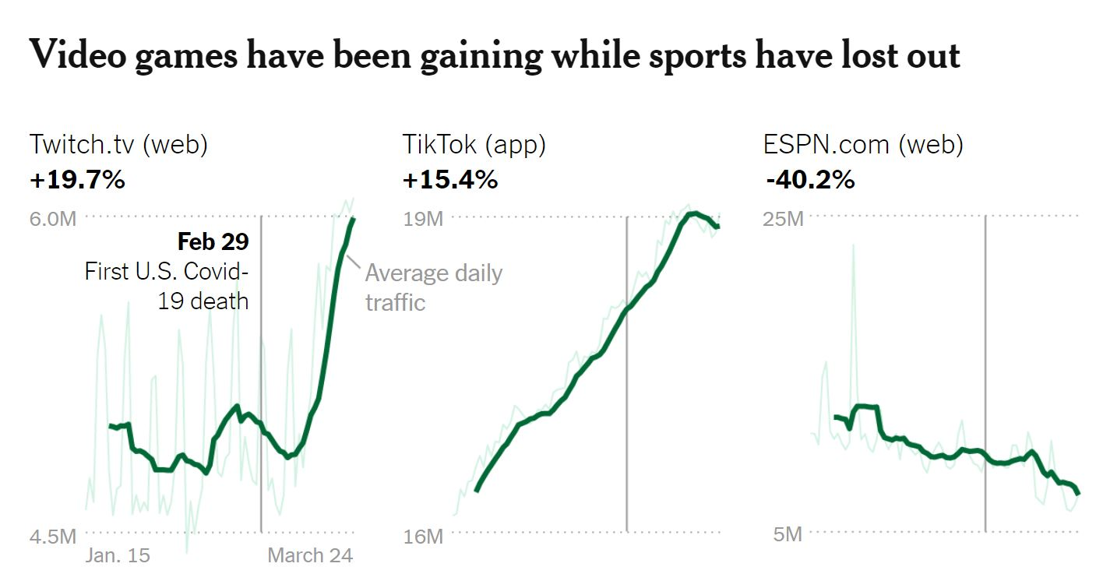

* + Twitch shot up by 20%
  + TikTok has steady increase
* 8 Charts on Internet Use around the world as countries grapple with COVID-19 (<https://www.pewresearch.org/fact-tank/2020/04/02/8-charts-on-internet-use-around-the-world-as-countries-grapple-with-covid-19/>)
* How Social Networks Are Surging and Changing During the COVID-19 Outbreak (<https://www.business2community.com/social-media/how-social-networks-are-surging-and-changing-during-the-covid-19-outbreak-02297720>)
  + Usage up- Twitter
    - “it’s really no longer about engagement on Twitter-people are merely using it to get information”
  + Usage Up – Twitch
    - People are gaming a lot more
  + Usage up- Instagram & Facebook
    - “The way in which people use these two networks is changing. You’re seeing more interactive content like challenges, workouts, and webinar-like content via livestreams. Insta is no longer the place to live your best life”
  + Usage up – LinkedIn
    - Thousands of American have been laid off and are looking for jobs
    - Those working from home have more downtime where they will “most likely go to time spend on LinkedIn to check up on colleagues and friends in the workplace”
* The pandemic infodemic: how social media helps(and hurts) during the coronavirus outbreak (<https://www.thedrum.com/opinion/2020/03/03/the-pandemic-infodemic-how-social-media-helps-and-hurts-during-the-coronavirus>)
  + Social media helps with spreading information, but misinformation and fear mongering is a problem
  + Social media helps with communicating
  + “people are eager to tell their stories and document their daily lives in the face of this deadly disease”
  + Scientists are using social media to collaborate
  + “regular people can simply use social media to provide moral support to those affected by the deadly virus”
  + “[social media]” fuel scientific collaboration, create fundraising opportunities, and – perhaps, most importantly – helps the quarantined people overcome their isolation”
* How Has the Coronavirus Changed How You Use the Internet (<https://www.nytimes.com/2020/04/09/learning/how-has-the-coronavirus-changed-how-you-use-the-internet.html>)
  + “While traditional social media sites have been growing, it seems that we want to do more than just connect through messaging and text- we want to see one another”
  + “Nothing is having a more profound impact on online activity than this change. School assignments are being handed out on Google Classroom. Meetings are happening on Zoom, Google Hangouts and Microsoft Teams”
  + “Several video game sites have had surges in traffic, as have sites that let you watch other people play. Twitch, the leading site for streaming game play, has had traffic shoot up 20 percent”
* Coronavirus has changed the way Americans use the internet: People are using their phones less and home computers more as video conferencing, online games and searches for updates about the pandemic spike (<https://www.dailymail.co.uk/sciencetech/article-8198157/Coronavirus-changed-way-Americans-use-internet-millions-lockdown.html>)

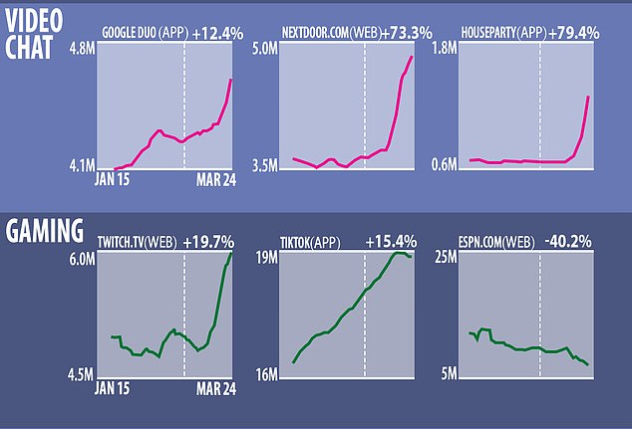

* This is how COVID-19 has changed media habits in each generation (<https://www.weforum.org/agenda/2020/04/covid19-media-consumption-generation-pandemic-entertainment/>)

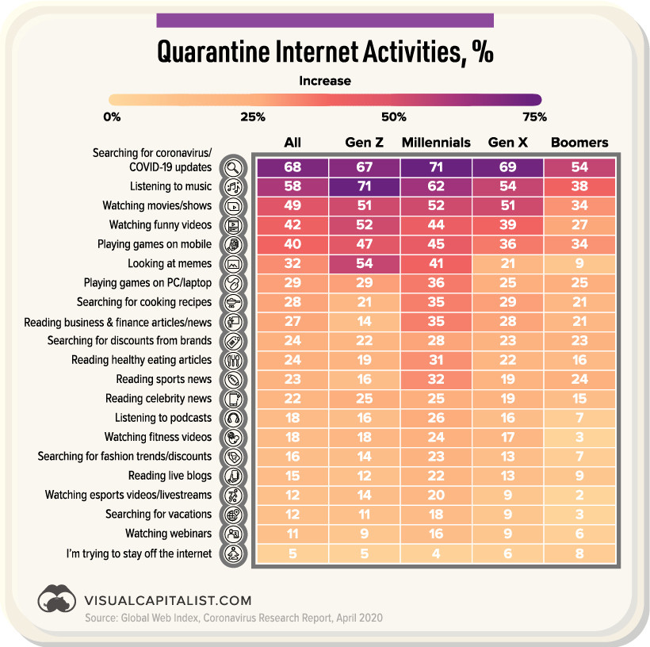

* <https://www.rivaliq.com/blog/coronavirus-on-social-media-engagement-for-brands/>

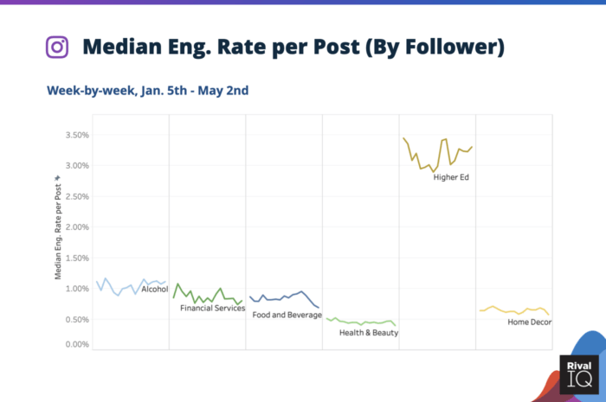

* <https://www.thedrum.com/opinion/2020/03/03/the-pandemic-infodemic-how-social-media-helps-and-hurts-during-the-coronavirus>
  + Netflix adds many new subscriptions as coronavirus hits the U.S.
* Case study for professional development:
  + Liz Fu: product designer, recent grad, intern at Airbnb
* Looked for differences between product designer and UI/UX designer
  + UI/UX designer: more focused on just design work, presenting their work
  + Product designer: research, could possibly lead designers/also work on designs, management, implementing, etc.